Ordinal-linguistic personification Synesthesia

🧠👤 What is Ordinal-Linguistic Personification (OLP) Synesthesia?
# Source: Chatgpt (GPT-4-turbo) at [7/24/2025]
Ordinal-linguistic personification (OLP) is a rare type of synesthesia in which ordered sequences — like numbers, letters, days of the week, or months — are involuntarily associated with personalities, genders, or emotions.

📘 Definition:
# Source: Chatgpt (GPT-4-turbo) at [7/24/2025]
Ordinal-linguistic personification is a form of synesthesia where sequential concepts (like "Monday", "A", or "4") automatically evoke person-like traits, such as gender, age, mood, or personality.

🧒 Examples:
# Source: Chatgpt (GPT-4-turbo) at [7/24/2025]
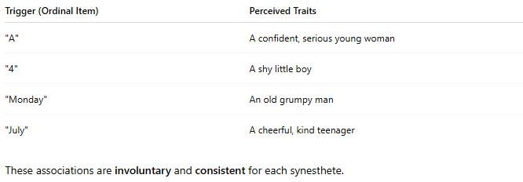
Trigger (Ordinal Item) | Perceived Traits
"A" | A confident, serious young woman
"4" | A shy little boy
"Monday" | An old grumpy man
"July" | A cheerful, kind teenager
These associations are involuntary and consistent for each synesthete.

Ordinal-linguistic personification Synesthesia photo
# Source: Windows ScreenShots at [7/26/2025]
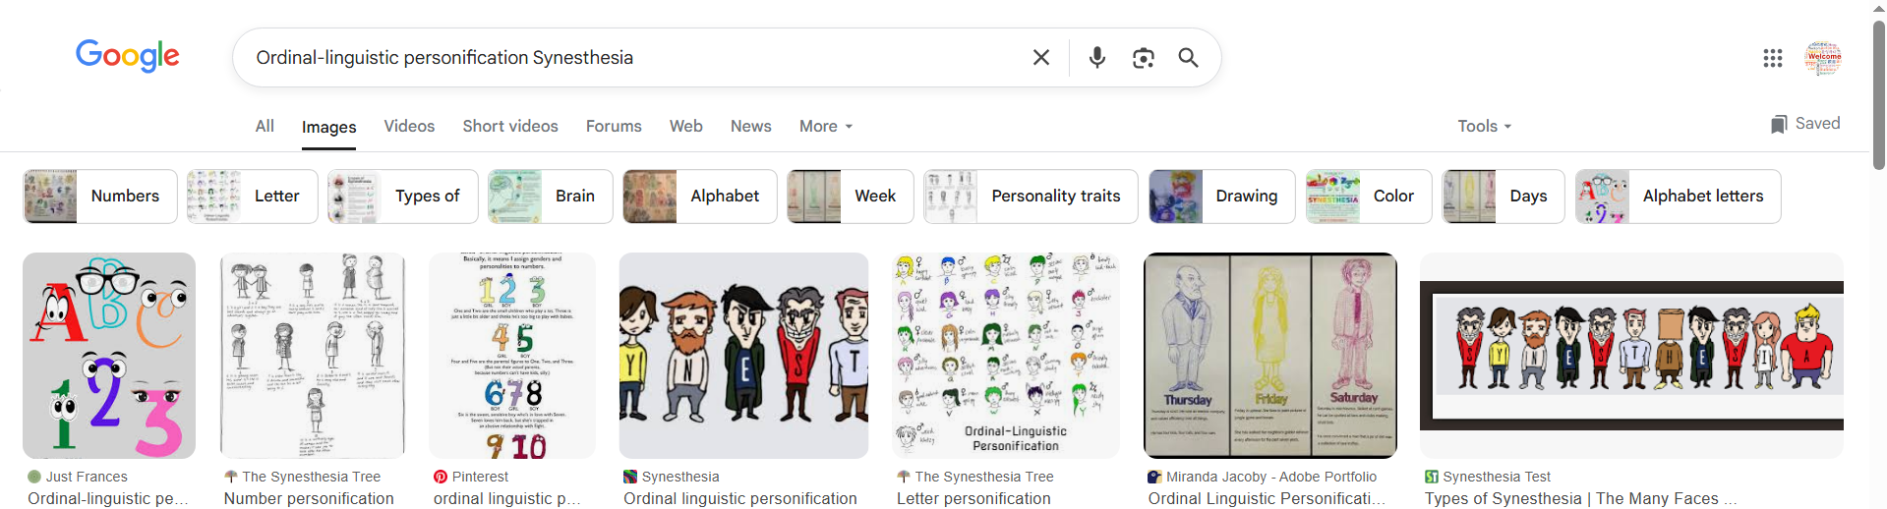
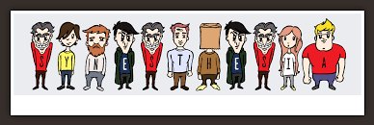
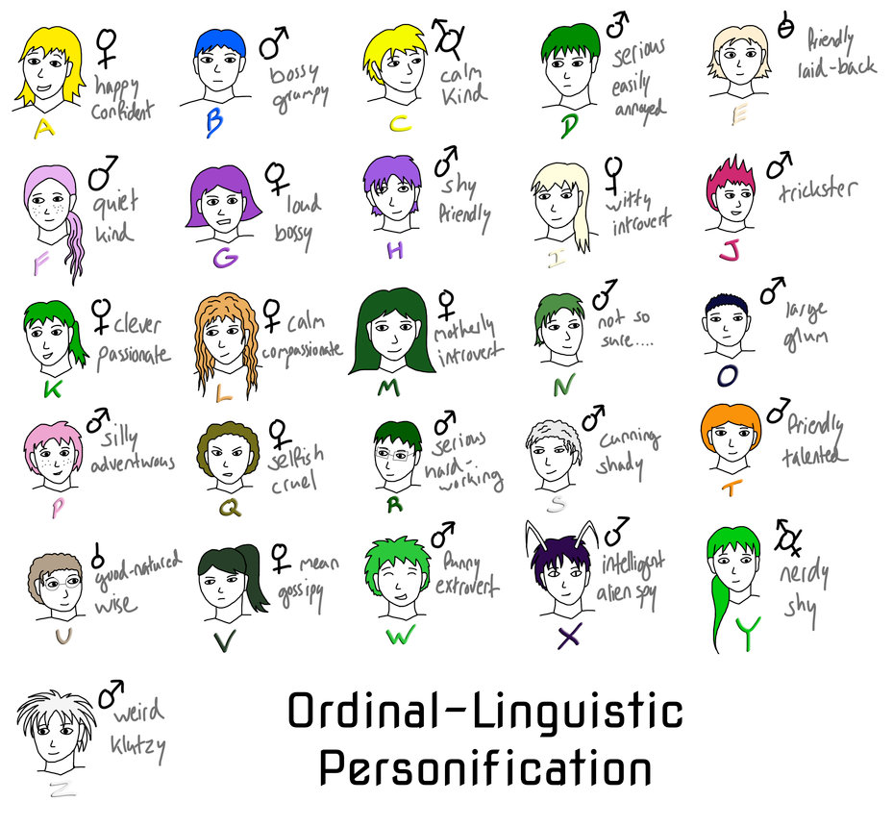
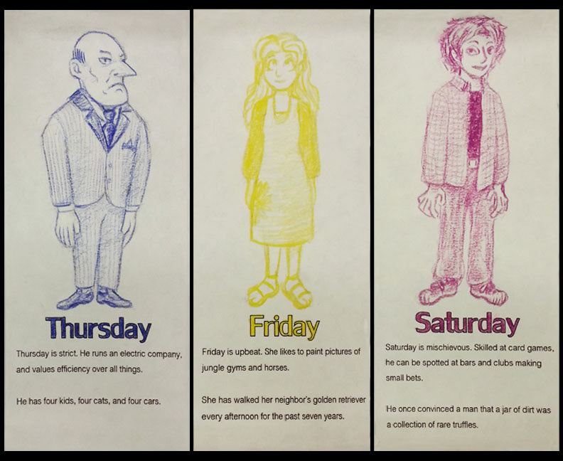

🔍 Key Characteristics:
# Source: Chatgpt (GPT-4-turbo) at [7/24/2025]
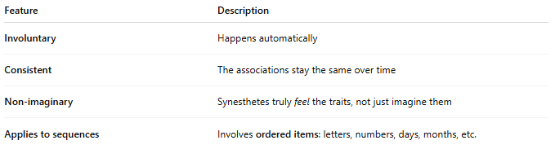
Feature | Description
Involuntary | Happens automatically
Consistent | The associations stay the same over time
Non-imaginary | Synesthetes truly feel the traits, not just imagine them
Applies to sequences | Involves ordered items: letters, numbers, days, months, etc.

🧠 Why Does It Happen?
# Source: Chatgpt (GPT-4-turbo) at [7/24/2025]
- Thought to be caused by cross-activation between:
  - Ordinal-processing regions (which handle sequences)
  - Social cognition areas (which understand people and traits)
- Not harmful — many synesthetes consider it normal or even helpful.

🧬 OLP vs Other Synesthesia Types:
# Source: Chatgpt (GPT-4-turbo) at [7/24/2025]
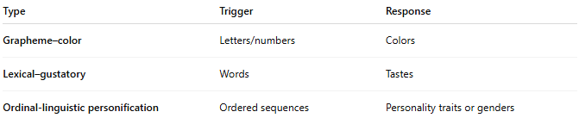
Type | Trigger | Response
Grapheme–color | Letters/numbers | Colors
Lexical–gustatory | Words | Tastes
Ordinal-linguistic personification | Ordered sequences | Personality traits or genders

✅ Summary:
# Source: Chatgpt (GPT-4-turbo) at [7/24/2025]
Ordinal-linguistic personification (OLP) is when things like numbers or weekdays feel like people with personalities — such as seeing "5" as a kind grandmother or "Tuesday" as a jealous teenager.
It is involuntary, consistent, and a fascinating example of how the brain mixes abstract sequences with human-like traits.

